

Senior Design
ENG EC 463
Boston University Electrical & Computer Engineering
The Triton Test Report 2

Team 25

Required Materials

Hardware:
- Raspberry Pi 3B
- USB-A to Micro cable
- Wall Block supplying 5V and 2.4 Amps DC OR 5V Rechargeable Battery
- OAK-D S2
- iPhone
- Lightning to USB-C cable
- Mac
- StereoPi Slim V2
- ABS/PLA Filament
- Servo Motor

Software:
- Bluetooth Python Script
  - Connect the Triton (Raspberry Pi) to the iOS application
  - Read from the OAK-D and send a photo via Bluetooth to the iOS application
- Camera Distance Recognition and Object Tracking Python Script
  - Determine object distance
  - Alert if an object is within a certain distance relative to the camera
  - Track a given target to give more detailed distance information
- iOS Application
  - Receive OAK-D serialized image over a Bluetooth connection
  - Present an alternative 2-D top-down display of detected objects near the boat
  - Demonstrate an improved UI with partitioned information on different pages
- StereoPi Software
  - Use a depth mapping to determine the distance of an object from the cameras
Setup

There are three primary portions of our prototype: the iPhone running an iOS application, the Raspberry Pi running a Bluetooth GATT server which controls the OAK-D camera and sends an image over to the iPhone application via BLE, and the printed enclosure for the project. There are other portions of the prototype that are still being integrated such as the StereoPi cameras which will use depth sensing, as well as other features of the iOS application.

Pre-Testing Setup:

Raspberry Pi
- Flash the Raspberry Pi 3b’s SD card with the Raspberry Pi OS 64-bit image
- Clone our git repository onto the pi
- Activate our virtual environment
- Open the /Senior-Design-Sailboat-Nav-2025/RPI-BLUETOOTH/ folder
- Run the bluetooth.py script (python3 bluetooth.py)

iPhone/Mac
- Download XCode
- Clone git repository
- Open the /Senior-Design-Sailboat-Nav-2025/Triton/ folder in XCode
- Connect iPhone to Mac via lightning to USB-C cable
- Put iPhone in Developer Mode
- Make sure that the app signature is a trusted developer in the iPhone running the app
- Press the play button in the top left corner of XCode
- Upload the boat_visualization code to the application and have it on its own dedicated page

OAK-D
- Install depthai and the necessary dependencies
- Plug into Raspberry Pi/Laptop
- Activate our virtual environment
- Open the /Senior-Design-Sailboat-Nav-2025/OAK-D/ folder
- Run the script (python distance_tracker.py)

Housing/Prints
- Create the housing design
- Print the STL files using ABS or PLA filament

StereoPi
- Install cameras (model needed) into ports
- Install Rasbian Debian 32-bit Legacy Edition onto an SD card
- Move PiCamera open source file folder onto the SD card
- Boot up PiCamera and install StereoVision and OpenCV via PiP
- Move the stereopi directory into a local directory in the Pi
- Run the 4_calibration.py file in order to calibrate cameras for depth mapping.
- Run the 5_dm_tune file to calibrate the cameras
- Run the 6_dm_video file

Testing Procedure

Circuit Diagram
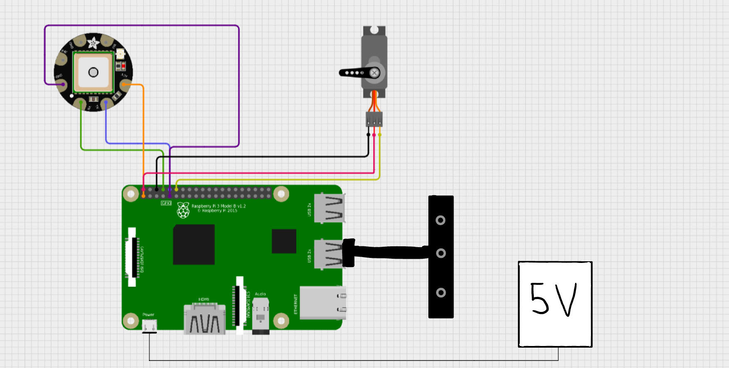
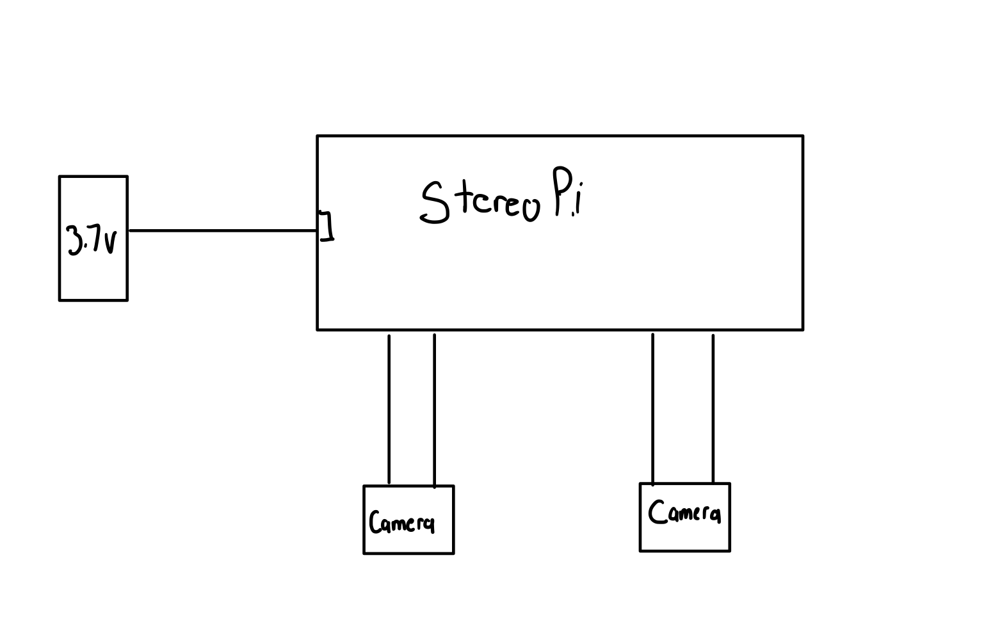

Hardware Pinout
Raspberry Pi | Peripheral
Pin 1, 3.3V | GPS 3.3V
Pin 9, GND | GPS GND
Pin 8, TX | GPS RX
Pin 10, RX | GPS TX
USB Port | OAK-D
Pin 4 5V | Servo 5V
Pin 6 GND | Servo GND
Pin 12 (GPIO 18) PWM0 | Servo PWM

Camera:
- Run the Python script for object tracking (python distance_tracker.py)
- Hold the camera at a fixed position
- Place someone in front of the camera from a set distance
- Have them slowly approach the camera
- Have them step back and then slowly move to the left or right
- The live feed on the monitor will place an outline around the person and show their distance and angle from the camera
- Have the person slowly walk away from the camera and observe as the warnings on the monitor go away
iOS Application:
- Run the python script for taking photos and bluetooth script (both will initiate on boot)
- Establish the bluetooth connection to the RaspberryPi
- Showcase the organized tabs of the application
- Show the images from the OAK-D appearing on the application
- Open the beta version of the top-down visualization

StereoPi:
- Run script for depth mapping (6_dm_video)
- Hold the cameras in such a position where they are pointing at the same direction
- Place an object at a fixed distance
- Move the object slowly towards the camera
- Showcase the adjusting colors of the depth map to indicate an object approaching

Housing/Prints:
- Showcase the design and print style of the housing
- Explain the choices made in the printing design
- Demonstrate the properly sized and fitted holes for the modules that will be placed within our connected to the housing
- Describe waterproofing techniques used and and considered (printing style, filament type, etc.)
- Show the OAK-D mount for the servo motor to eventually be used with the object tracking

Measurable Criteria
- The OAK-D camera will show a live view with an ROI (region of interest) around a detected object to showcase the distance of detected objects on the Raspberry Pi through a monitor
- The OAK-D camera will print the relevant ROI and object detected, and if the object is too close and location relative to the camera on the Raspberry Pi
- The iOS app will connect to the Raspberry Pi
- The iOS app will showcase a beta development visualization of the top-down object detection
- The application will receive the transmitted image taken from the OAK-D
- The housing will be printed with properly sized holes for mounting arms, clamps, and OAK-D
- The StereoPi cameras will be able to detect objects coming close to the camera

Score Sheet

Task | Completion (Y/N)
OAK-D displays a live feed | ✓
OAK-D has a box outline around the tracked object/person | ✓
OAK-D prints out a message that an object is too close with its distance accurate within .05m | ✓
iPhone is able to detect and connect to the pi | ✓
OAK-D image is uploaded and visible on the iOS app | ✓
Top-Down visualization is loaded on the app | ✓
Enclosure is printed with fitted holes | ✓
Clamps fit in the enclosure | ✓
StereoPi showcases a depth mapping | ✓

Conclusions

This second prototype testing aims to show the development of our project from our initial testing last semester. We have built up from the first prototype, creating more complex functions with the OAK-D, an improved user interface on the iOS application, and the GPS module as a whole being completed. We also introduced the development of more modules to create a more complete system with a preliminary implementation of a servo motor, a printed design for the housing with waterproof capabilities in mind, a StereoPi for side view distance detection, and an alternative visualization of detected objects near the boat. These improvements and new modules show our iterative development to create a product that meets our desired design goals. Specifically, the object tracking as opposed to raw distance detection with the OAK-D will give more accurate data for how far objects are from the boat and will more seamlessly be incorporated to the alternative view. Additionally, the housing design shows the beginning of our final phase of development where our individual modules can come together into one package for the user to install. There are more developments to be made and modules to be developed this marks an effective step towards completing our project.

